Aim:
Aim of this experiment is to investigate the small signal AC model of diode and learn more about usage of themn.

Experimental Work:

1) a. In this part we setupped the circuit in preliminary work. First we put R=3,9k , this is for part 1. Then we put R=56k and this is for part 2. we turned off the generator and measured the DC voltage drop across the diode

 | Part1 | Part2 | Part3
DC voltage drop across the 1k | 0,9277V | 0,1890V
VDQ | 0,6042 | 0,4901V

b. In this part we turned on the generator and measured the signals by oscilloscope.
The gain for part 1 and part 2;

AV=Vout/Vin=82mV/100mV=0,82 Av=0,947 in preliminary work (for part 1)

AV=Vout/Vin=58mV/100mV=0,58 (for Part 2)


- 1 –
c.

 | Part1 | Part2 | Part3
VM | 910 mV | 176 mV

d. This time we changed the oscilloscope to X-Y mode and measured the signals of input and output for part1 and part2.
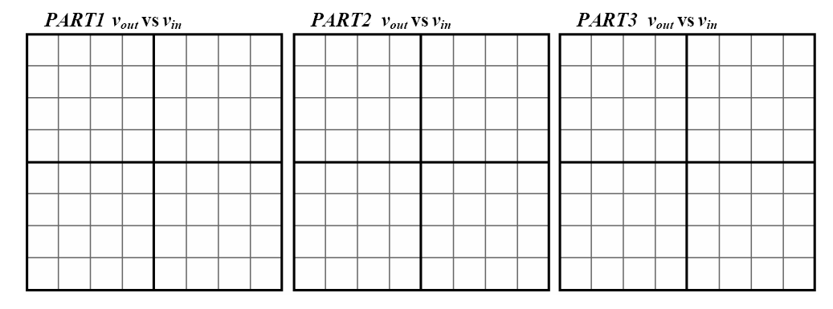

- 2 -

